REPORT
Made by: Dargulova Aruzhan, Sardarbekova Akaru
Group: SE-2116
Project Name: Hot Spot
Project description
We have decided to make a website dedicated to wide variety of entertainment and cultural events in the city, focusing on the accessibility and usefulness of events for citizens. The HOTTEST and TOP places in certain fields will be published in the form of posts.
Technical part
Front End | Back End
HTML  CSS  Bootstrap | JavaScript  Node.js  Express.js  jQuery  …

Possible user roles and their functions
User | Function
Guest/user | - choosing sections  - sign up/sign in  - add your top places to favorites  - leave comments  - set ratings  - suggest personal list of events  - request a list on specific topics
Admin | - add, edit, delete posts/sections  - delete certain users

Analogies
https://sxodim.com/astana
https://www.atlasobscura.com/things-to-do/new-york
https://gorod24.online/

After making some research and analyses of similar websites we have highlighted some features that we can implement in our website. For example:
- Choosing the cities, searching by keywords, calendar, categories
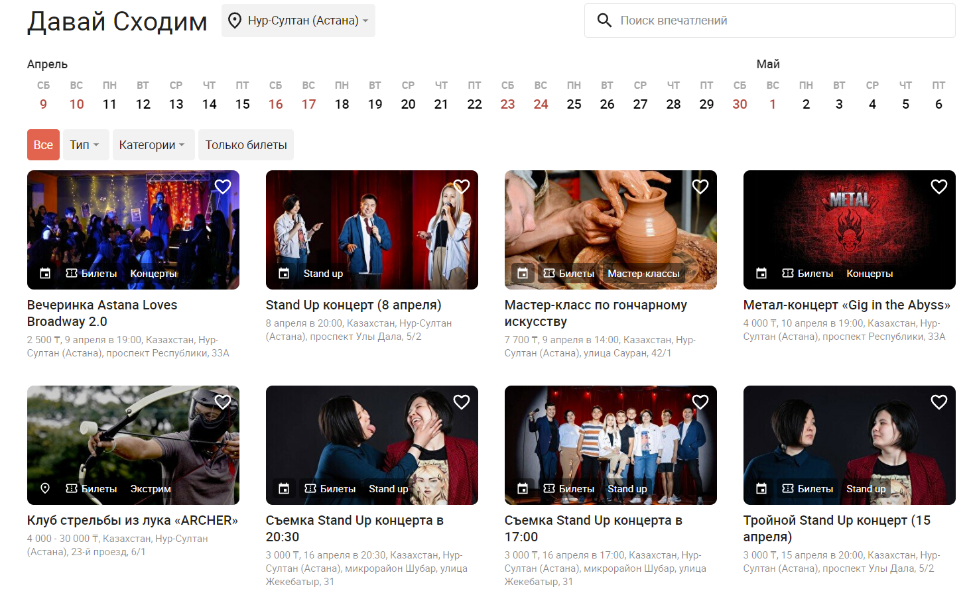
- Adding map(2GIS)
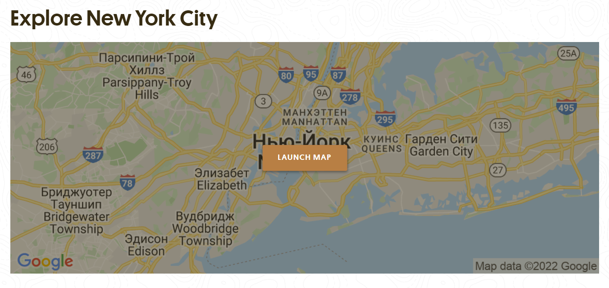
- User profile, settings, favorites, post suggestions
P.S. the same one for admin’s profile, but with another functions

